**INDEX**

|  |  |  |
| --- | --- | --- |
| **Sr.**  **No.** | **Title** | **Sign** |
| 1 | Assignment No 1 |  |
|  | Assignment No 2 |  |
| 3 | Assignment No 3 |  |
| 4 | Assignment No 4 |  |
| 5 | Assignment No 5 |  |
| 6 | Assignment No 6 |  |

**Assignment No 1**

**Q1) Write a php program to find maximum of three numbers.**

**Code:**

<?php

$num1=20;

$num2=15;

$num3=22;

if($num1>$num2 && $num1>$num3){

echo $num1;

}

else{

if($num2>$num1 && $num2>$num3){

echo $num2;

}

else

echo $num3;

}

?>

Output

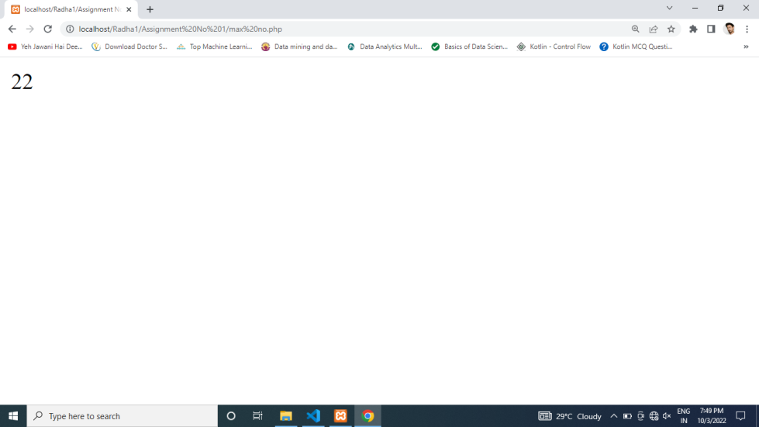

**2. Write a php program to swap two numbers.**

Code:

<?php

$a = 15;

$b = 27;

echo "\nThe number before swapping is:\n";

echo "Number a =".$a." and b=".$b;

$temp = $a;

$a = $b;

$b = $temp;

echo "\nThe number after swapping is: \n";

echo "Number a =".$a." and b=".$b."\n";

?>

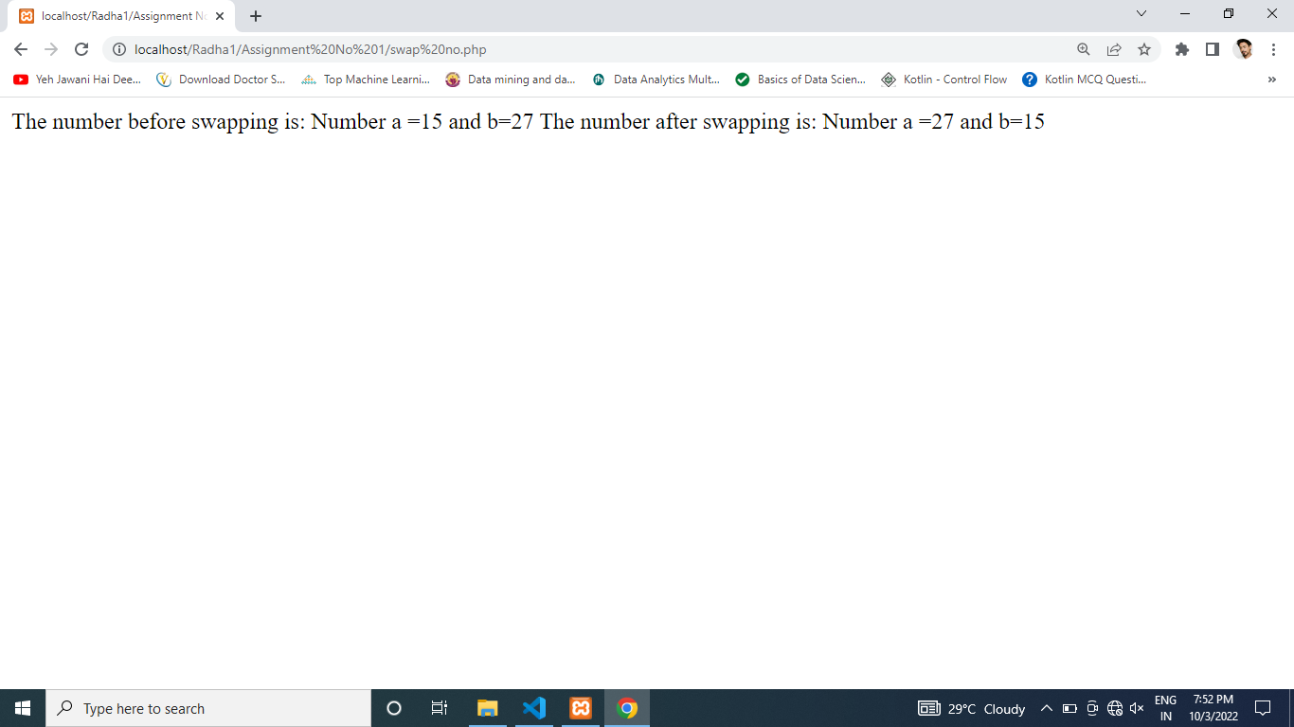

**3. Write a php script to find out the sum of the Individual Digits.**

**Code:**

<?php

$num = 12345;

$sum=0; $rem=0;

for ($i =0; $i<=strlen($num);$i++)

{

$rem=$num%10;

$sum = $sum + $rem;

$num=$num/10;

}

echo "Sum of digits 12345 is $sum";

?>

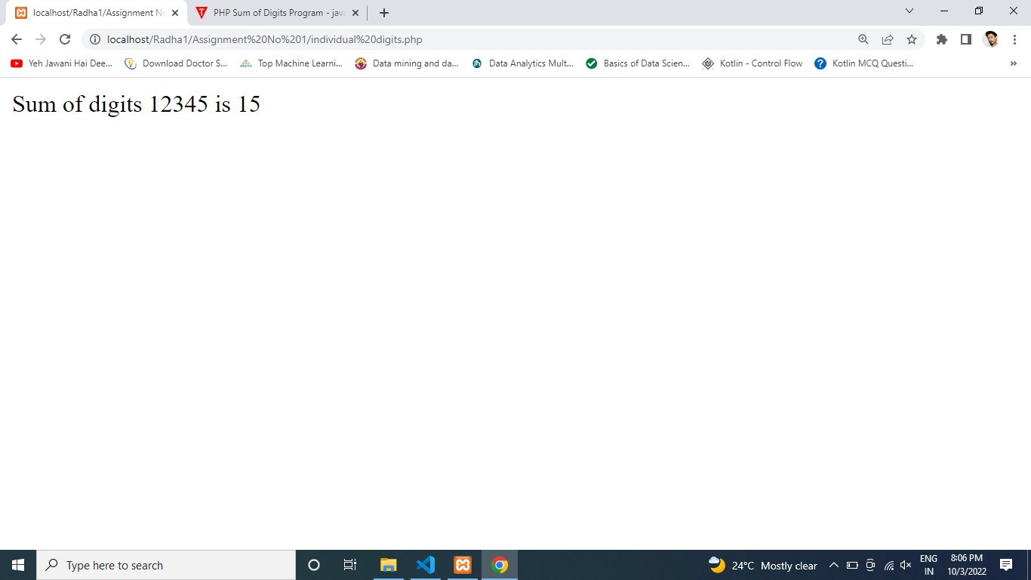

**4. Write a php script to find out check whether the given number is Palindrome or no.**

<?php

$num = 10;

$p=$num;

$revnum = 0;

while ($num != 0)

{

$revnum = $revnum * 10 + $num % 10;

$num = (int)($num / 10);

}

if($revnum==$p)

{

echo $p," is Palindrome number";

}

else

{

echo $p." is not Palindrome number";

}

?>

Output

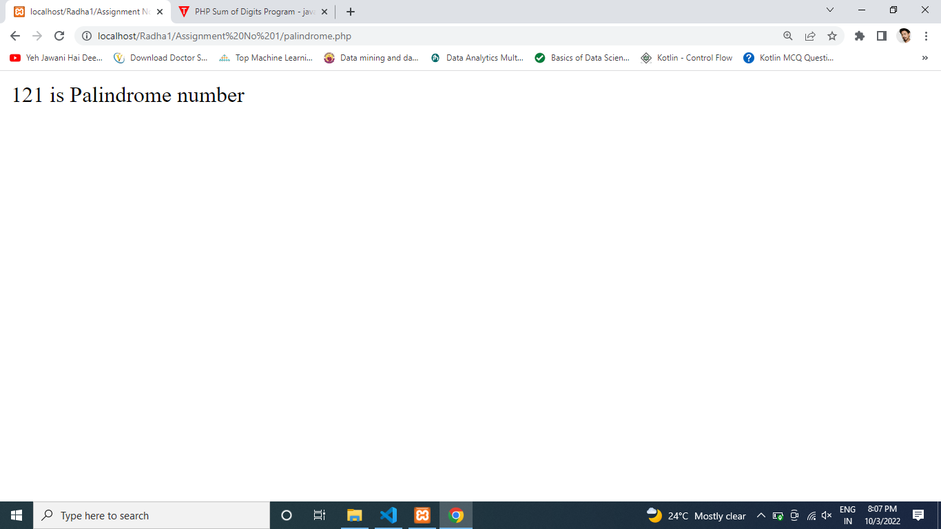

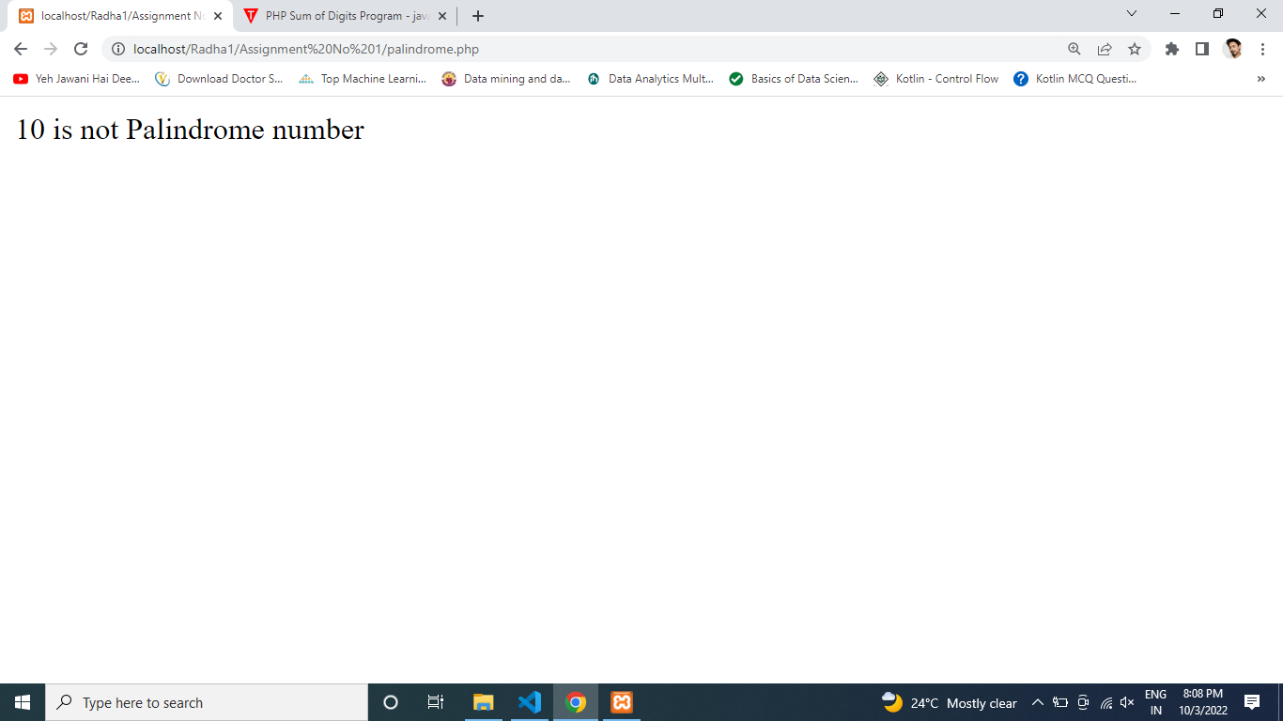

5. Write a php script to get the php version and configuration information.

<?php

phpinfo();

?>

Output :

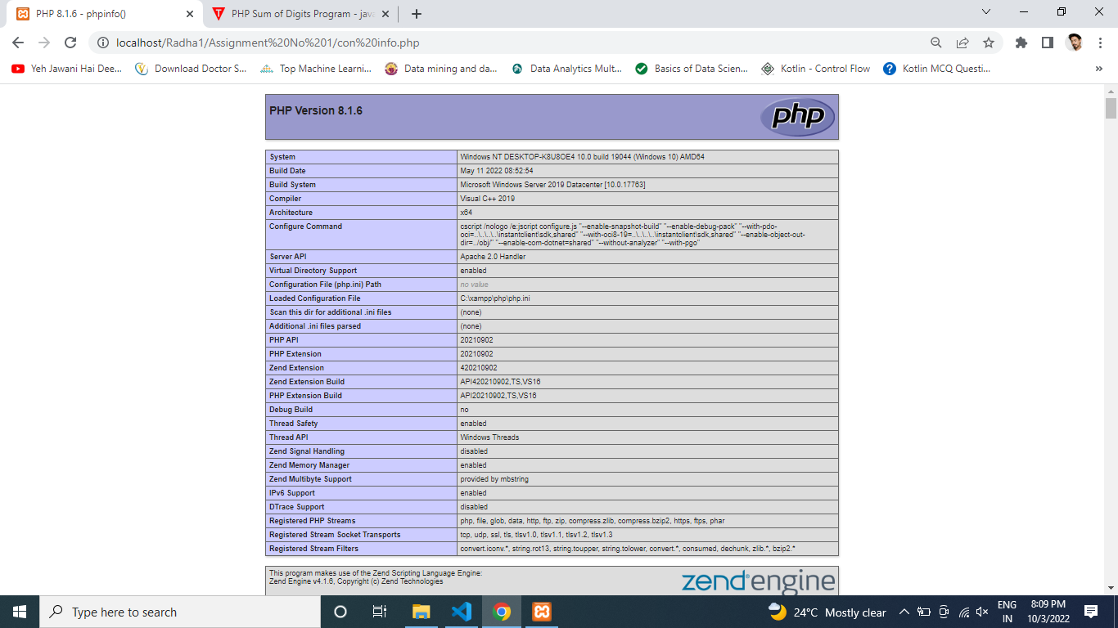

**6. Write a php script to display the following strings.**

<?php

echo "Tomorrow I \'ll learn PHP global variables."."\n";

echo "This is a bad command : del c:\\*.*"."\n";

?>

Output:

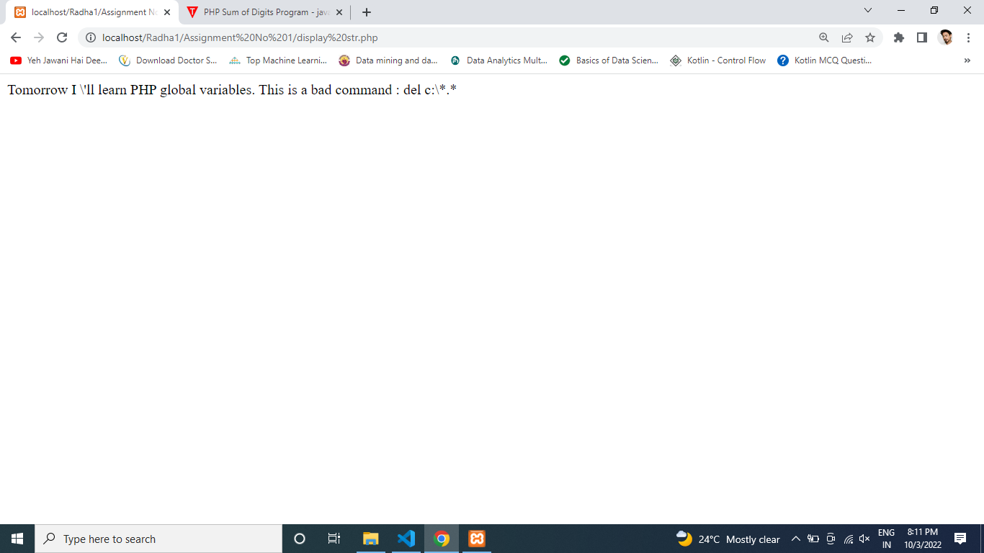

**7. $var=’PHP Tutorial’. Put this variable into the title section, h3 tag and as an anchor text within an html document.**

<?php

echo "<html>";

echo "<head>";

echo "<title>";

echo "PHP TUTORIAl";

echo "</title>";

echo "<body>";

echo "<h3>PHP TUTORIAL</h3>";

echo "<hr>";

echo "<p>PHP, an acronym for Hypertext Preprocessor, <br> is a widely-used open source general-purpose scripting language. <br>It is a cross-platform, HTML embedded server-side scripting language <br>and is especially suited for web development.</p>";

echo "</body>";

echo "</head>";

echo "</html>";

?>

Output:

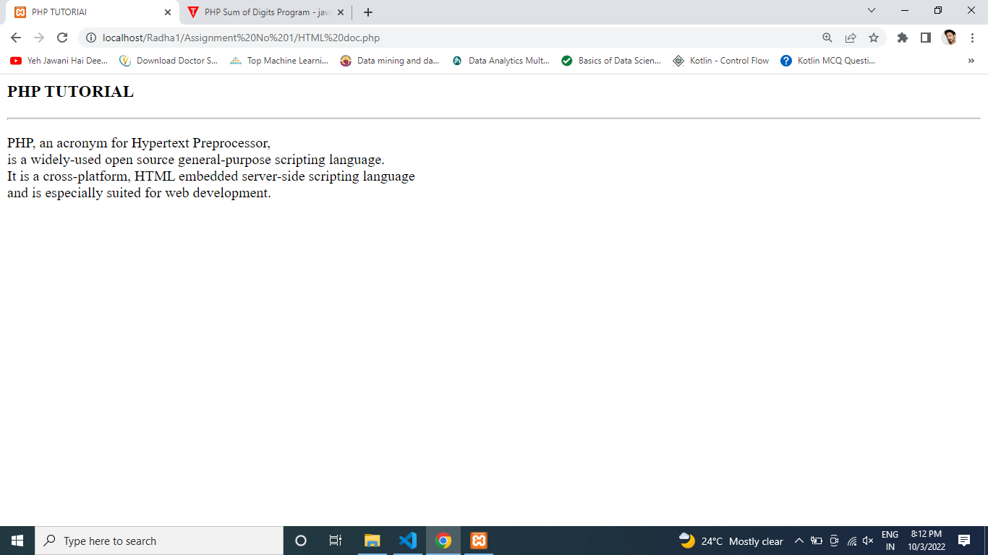

**Assignment No 2**

**1. Write a PHP function to test whether a number is greater than 30, 20 or 10 using ternary operator.**

<?php

function trinary_Test($n){

$r = $n > 30

? "greater than 30 <br>"

: ($n > 20

? "greater than 20<br>"

: ($n >10

? "greater than 10<br>"

: "Input a number atleast greater than 10!"));

echo $n." : ".$r."\n";

}

trinary_Test(32);

trinary_Test(21);

trinary_Test(12);

trinary_Test(4);

?>

Output:

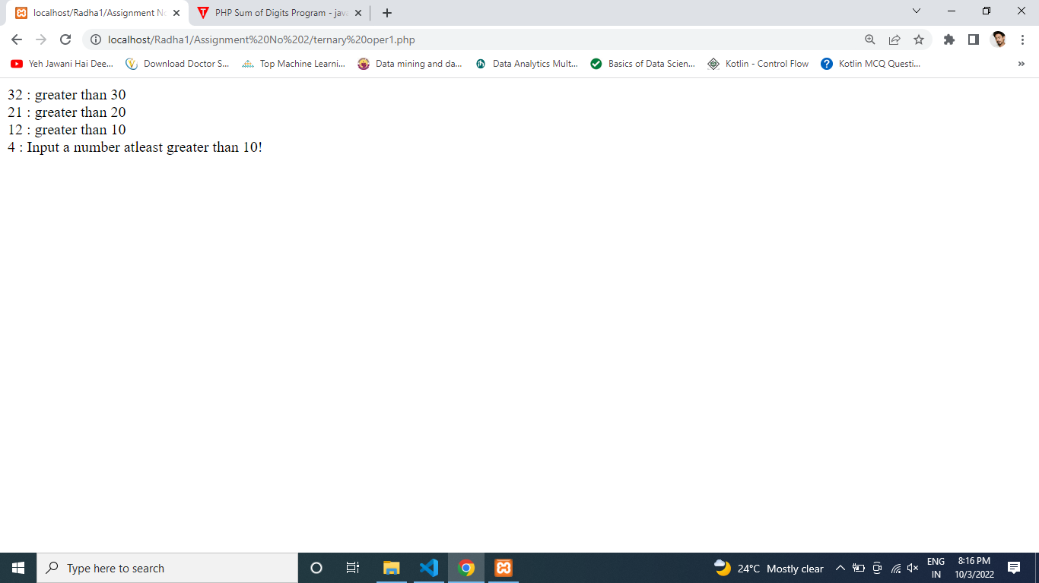

**2 Write a PHP program to print sum of digits..**

<?php

$number=345;

$sum=0;

for($i=0;$i<=strlen($number);$i++)

{

$sum=$sum+$number%10;

$number/=10;

}

echo"sum of digit 345 is $sum";

?>

Output :

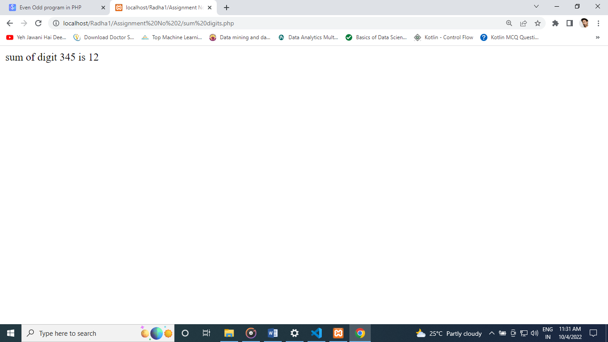

**3. Even or odd**

<?php

$num = 13;

$count=0;

for ( $i=1; $i<=$num; $i++)

{

if (($num%$i)==0)

{

$count++;

}

}

if ($count<3)

{

echo "$num is a prime number.";

}

else

{

echo "$num is not a prime number.";

}

?>

Output:

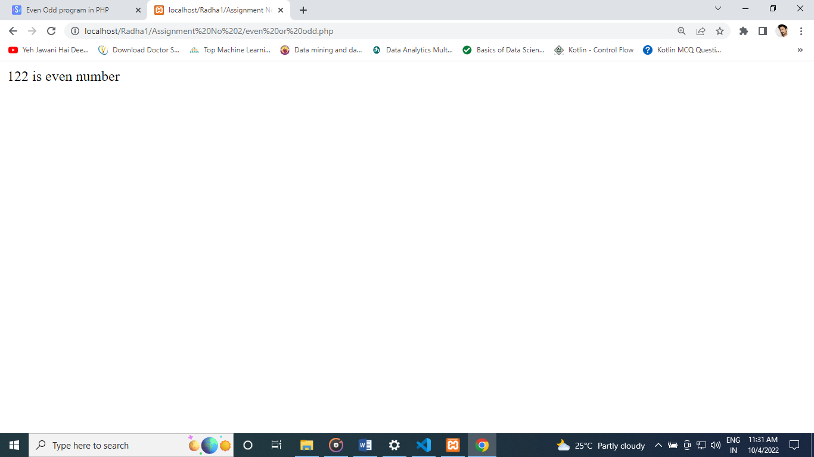

**4. Write a PHP program to check prime number.**

<?php

$num = 13;

$count=0;

for ( $i=1; $i<=$num; $i++)

{

if (($num%$i)==0)

{

$count++;

}

}

if ($count<3)

{

echo "$num is a prime number.";

}

else

{

echo "$num is not a prime number.";

}

?>

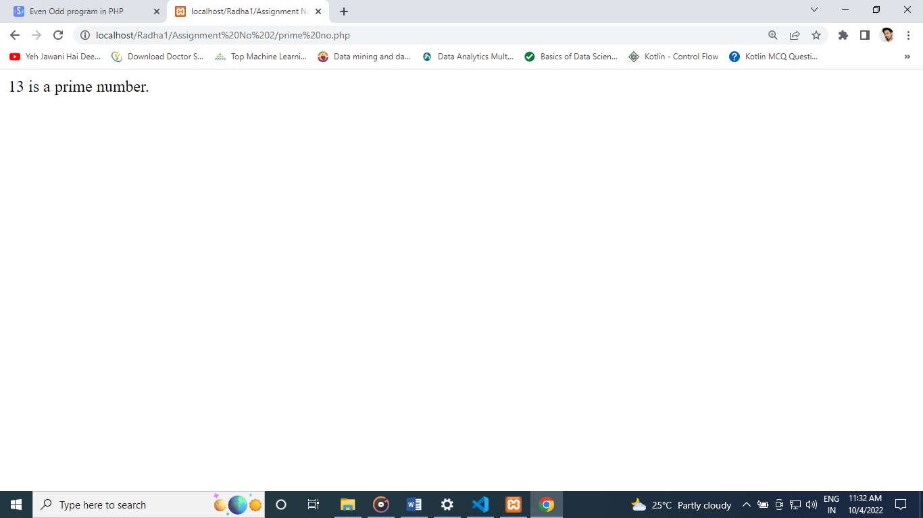

**5. Write PHP program to print table of a number.**

<?php

define('NUM', 12);

for($i=1 ; $i<=10 ; $i++)

{

echo $i*NUM;

echo '<br>';

}

?>

Output :

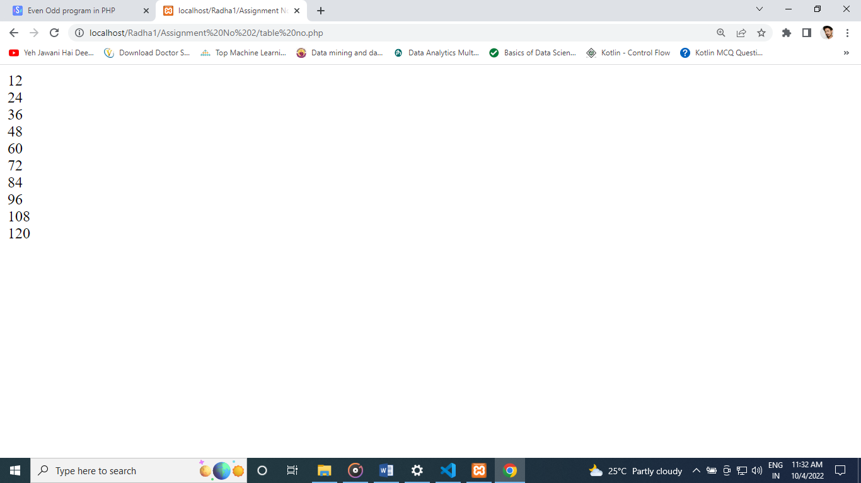

**6. Write a PHP program to print factorial of a number.**

<?php

$n = 10;

$f = 1;

for ($i=$n; $i>=1; $i--)

{

$f = $f * $i;

}

echo "$n! = $f";

?>

Output:

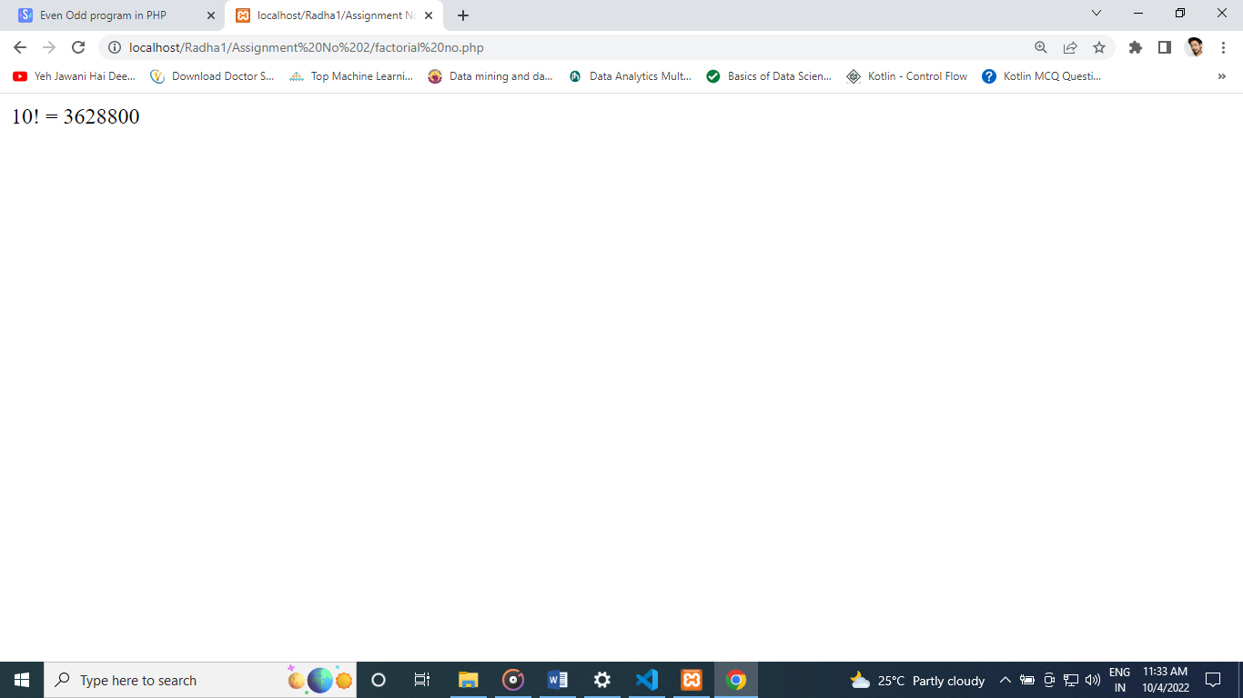

**7. Write a PHP program to check armstrong number.**

<?php

$num = readline("Enter the number: ");

$total = 0;

$x = $num;

while ($x != 0) {

$rem = $x % 10;

$total = $total + $rem * $rem * $rem;

$x = $x / 10;

}

if ($num == $total) {

echo "Yes $num is an Armstrong number";

} else {

echo "No $num is not an armstrong number";

}

?>

Output :

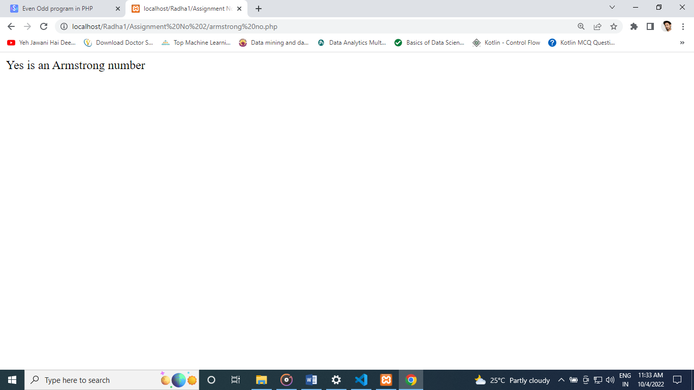

**8. Write a PHP program to check palindrome number.**

<?php

$num = 123454321;

$x = 0;

$n =$num;

while(floor($num))

{

$mod = $num%10;

$x = $x * 10 + $mod;

$num = $num/10;

}

if($n==$x)

{

echo "$n is a Palindrome number.";

}

else

{

echo "$n is not a Palindrome number.";

}

?>

Output :

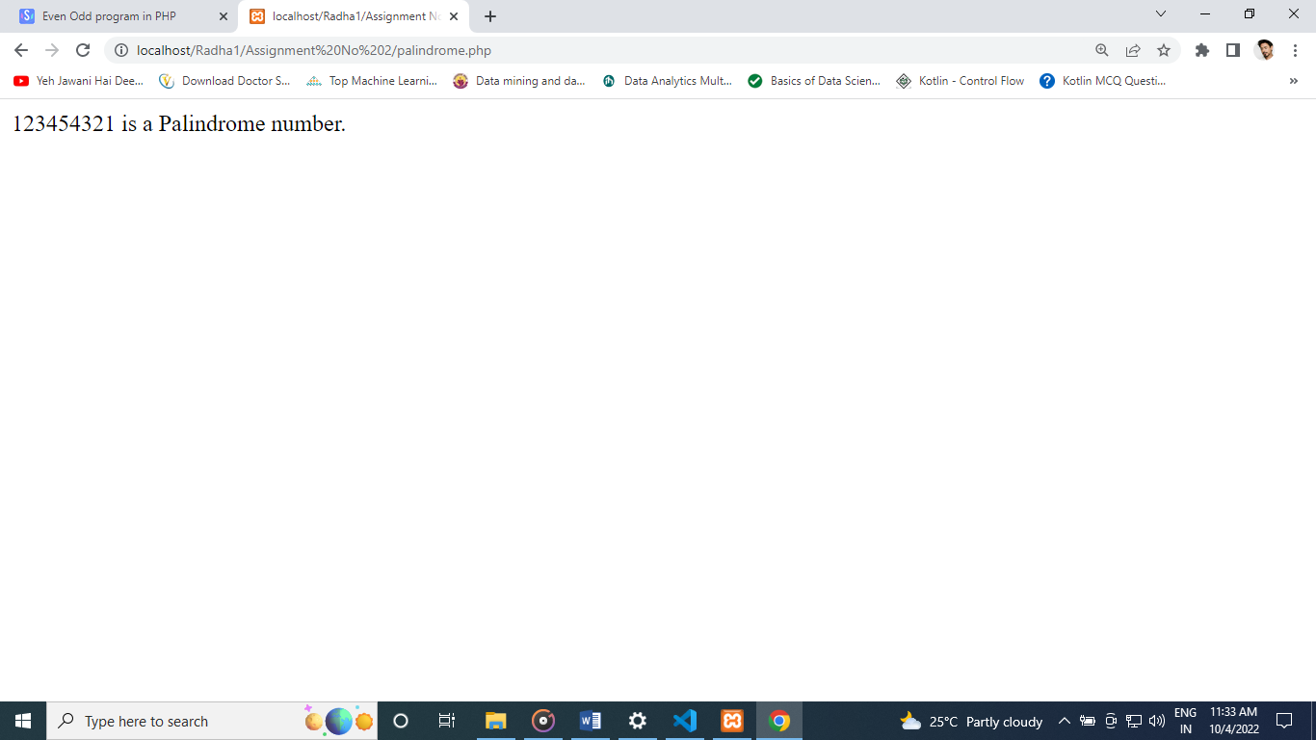

**9. Write a PHP program to print fibonacci series without using recursion and using recursion.**

<?php

$num = 0;

$n1 = 0;

$n2 = 1;

echo "<h3>Fibonacci series for first 12 numbers: </h3>";

echo "\n";

echo $n1.' '.$n2.' ';

while ($num<10 )

{

$n3 = $n2 + $n1;

echo $n3.' ';

$n1 = $n2;

$n2 = $n3;

$num = $num + 1;

}

?>

Output :

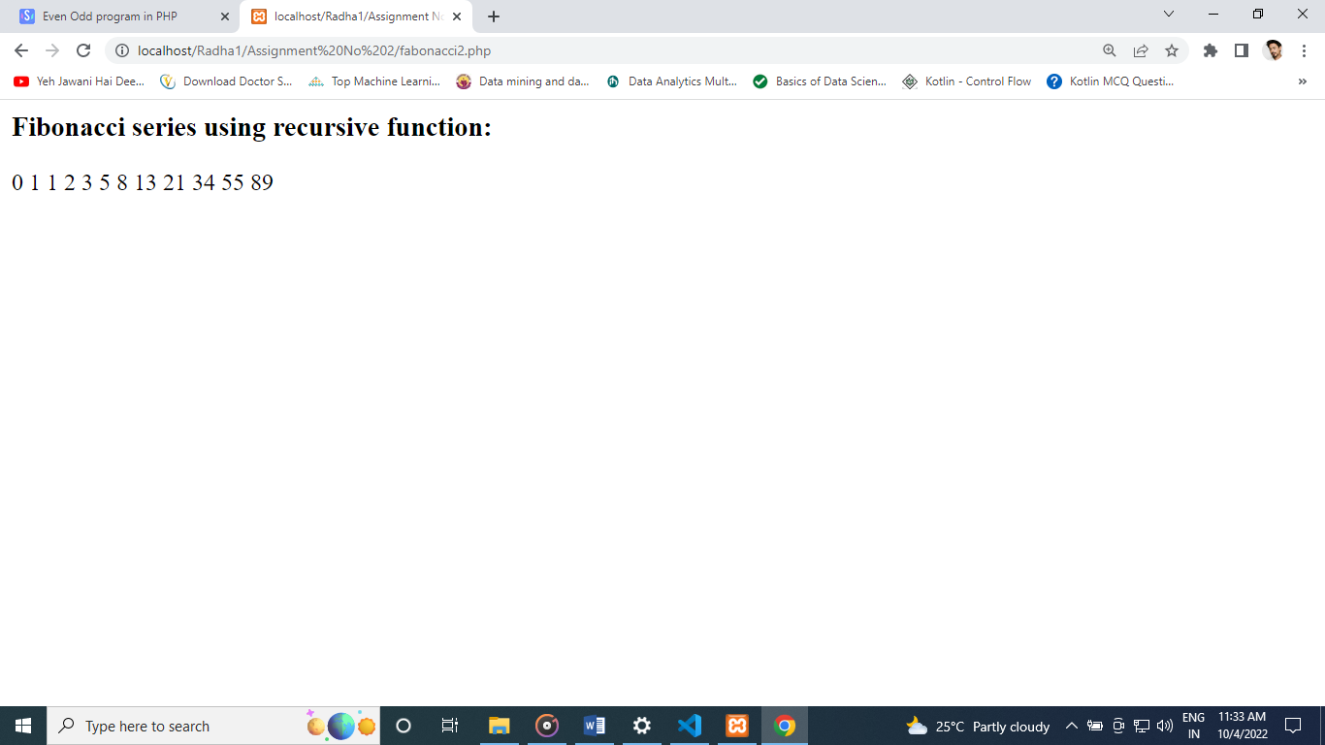

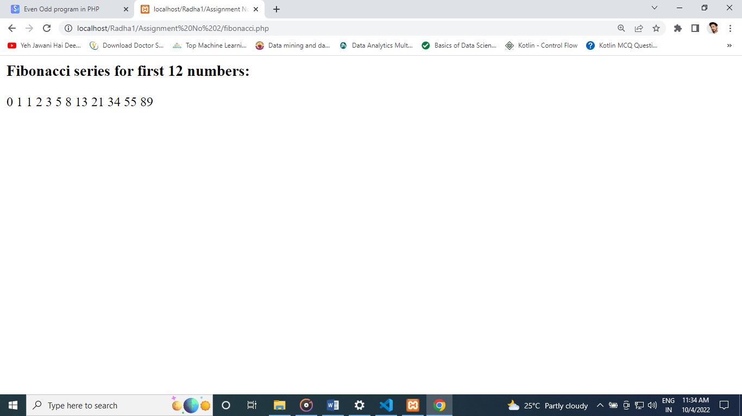

**10. Write a PHP program to reverse given number.**

<?php

$num = 123456789;

$x = 0;

$n =$num;

while(floor($num))

{

$mod = $num%10;

$x = $x * 10 + $mod;

$num = $num/10;

}

echo "Reverse of $n is $x.";

?>

Output :

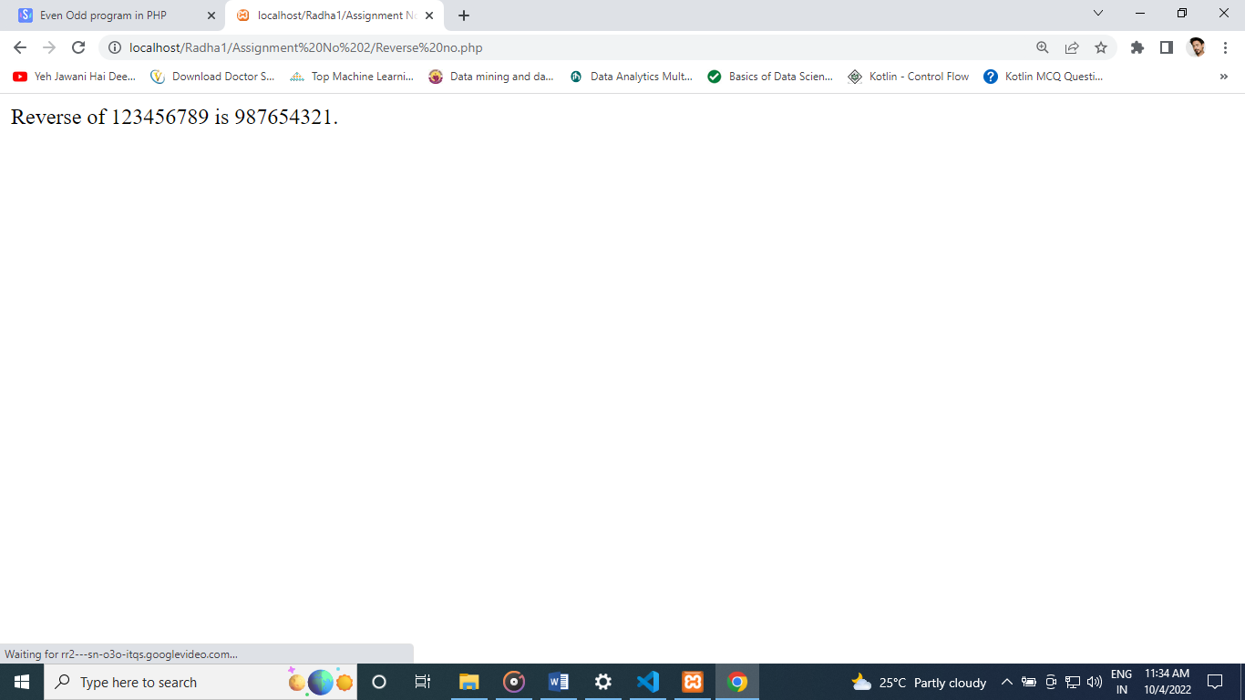

**11. Write a PHP program to reverse given string**.

<?php

echo strrev("Hello World!");

?>

Output :

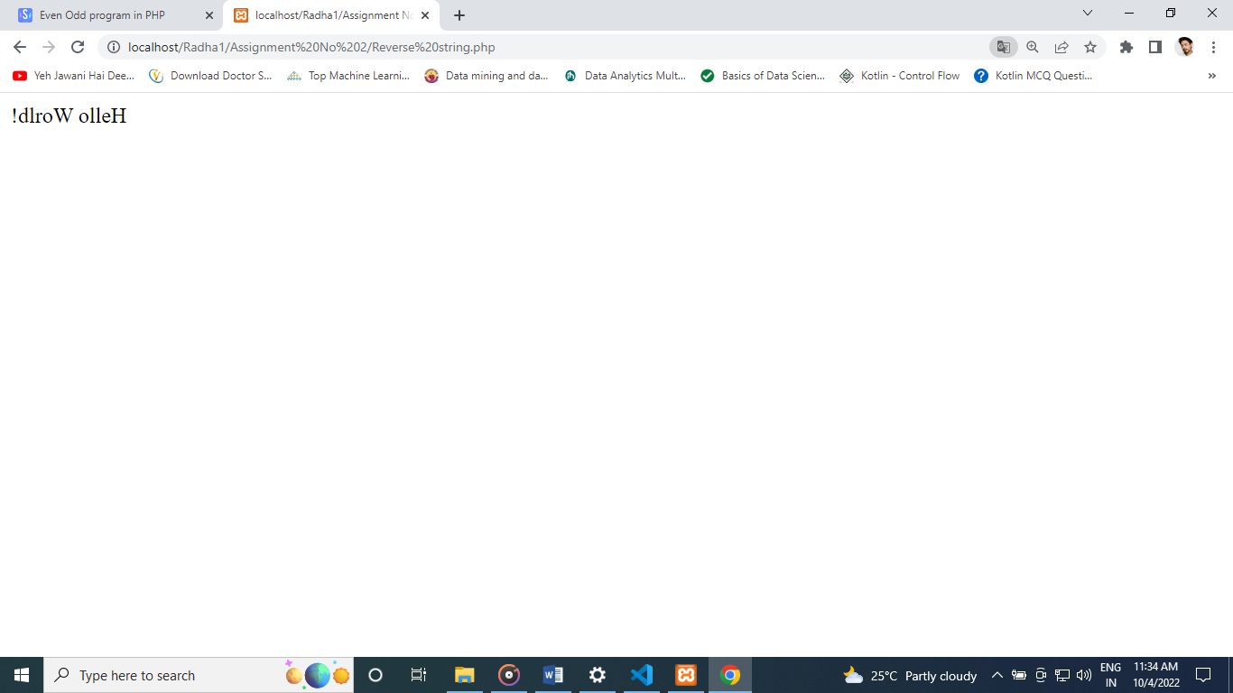

**12. Write a PHP program to add two numbers.**

<?php

$a=20;

$b=20;

$c=$a+$b;

echo "Sum: ",$c;

?>

Output :

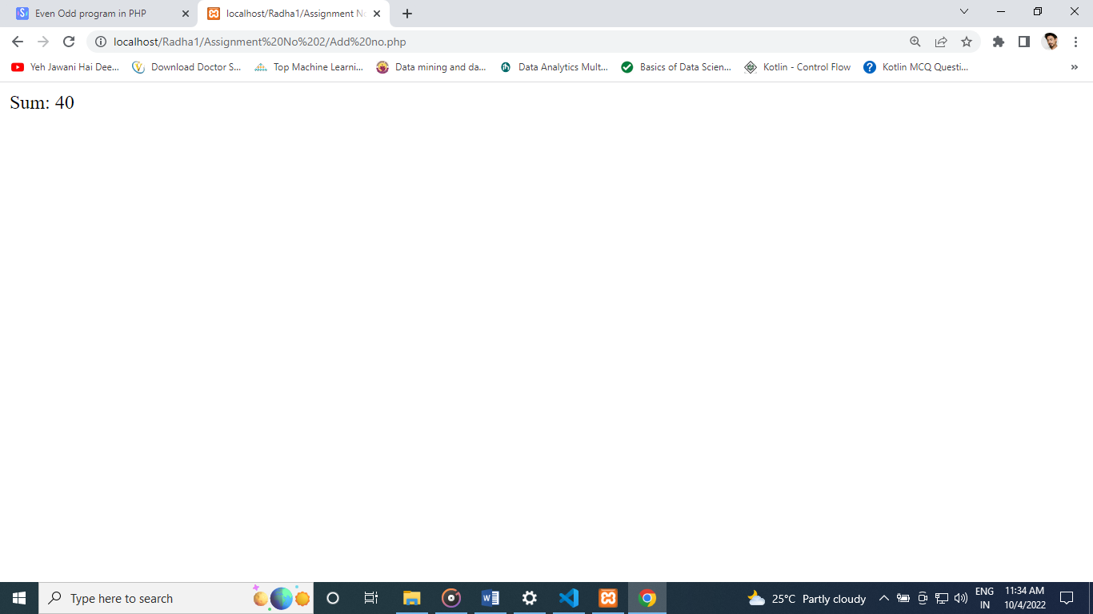

**13. Write a PHP program to subtract two numbers.**

<?php

$x=30;

$y=15;

$z=$x-$y;

echo "Difference: ",$z;

?>

Output :

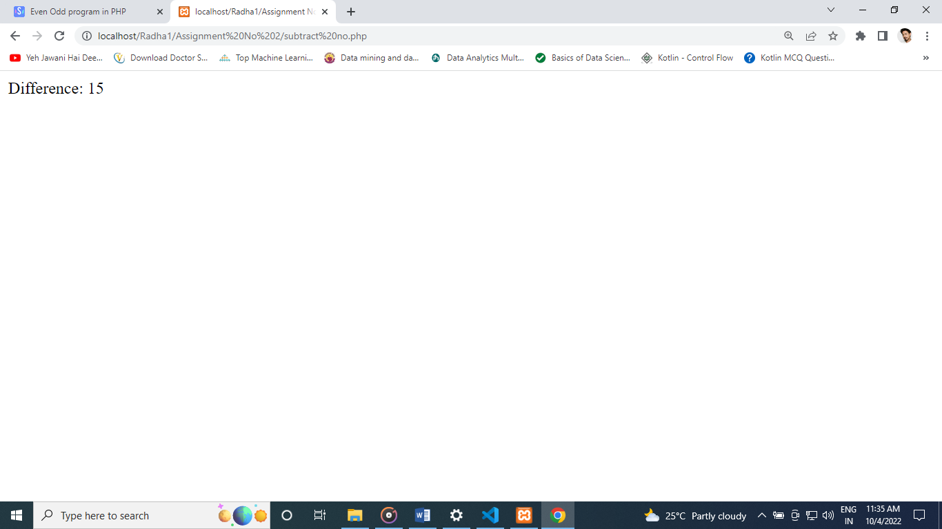

**14. Write a PHP program to find area of triangle.**

<?php

$b = 5;

$h = 7;

$a = NULL;

$a = (float)(($b * $h) / 2);

echo "\nArea of the triangle = " . $a . " sq. units";

?>

Output :

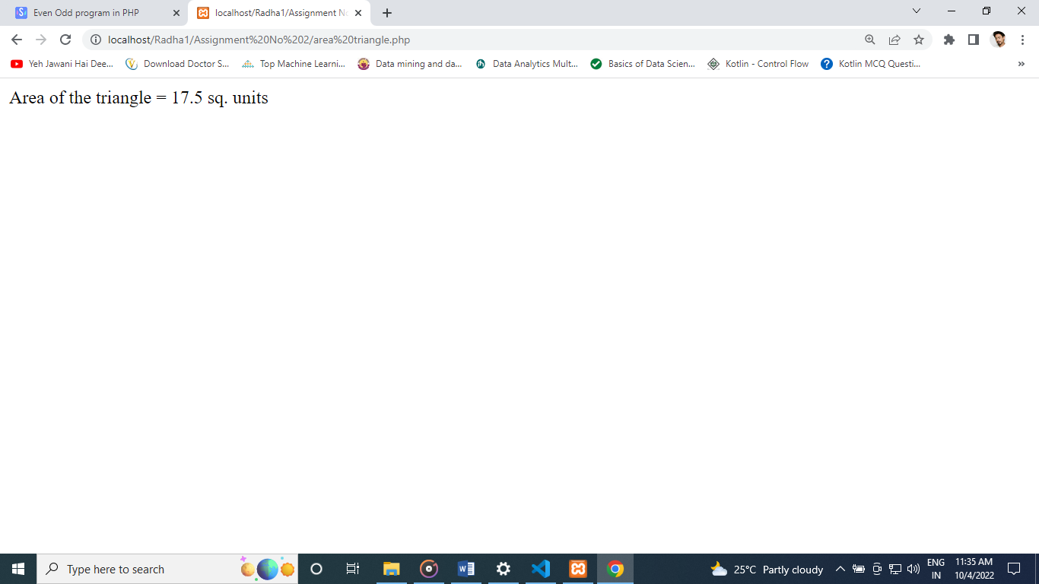

**15. Write a PHP program to find the area of rectangle.**

<?php

$length = 14;

$width = 12;

echo "Area of Rectangle is $length * $width= " . ($length * $width) . "<br />";

?>

Output :

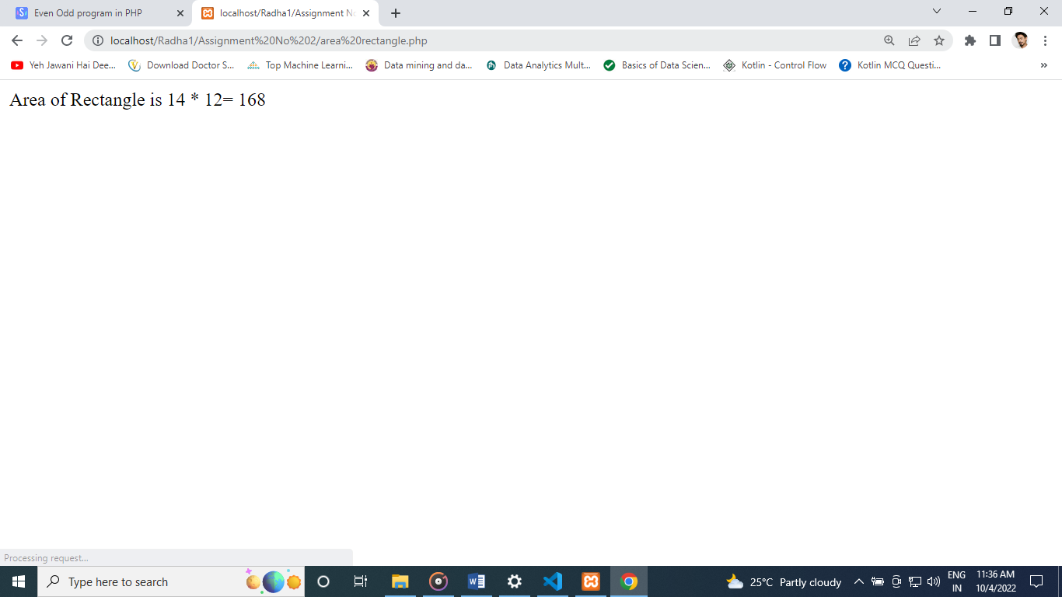

**16. Write a PHP program to find if the given year is leap year or not.**

<?php

$year = 2032;

if((0 == $year % 4) & (0 != $year % 100) | (0 == $year % 400))

{

echo "$year is a Leap Year.";

}

else

{

echo "$year is not a Leap Year.";

}

?>

Output :

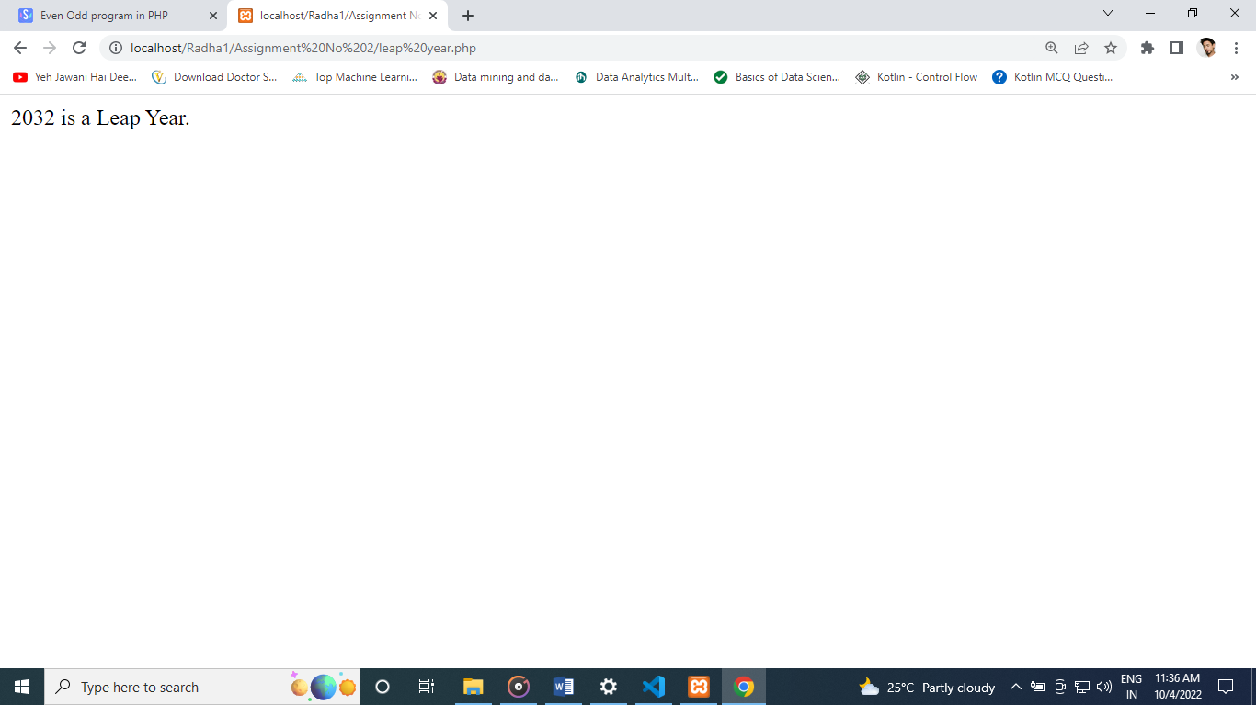

**17. Write a PHP program to print alphabet triangle.**

<?php

$alpha = range('A', 'Z');

for($i=0; $i<5; $i++){

for($j=5; $j>$i; $j--){

echo $alpha[$i];

}

echo "<br>";

}

?>

Output :

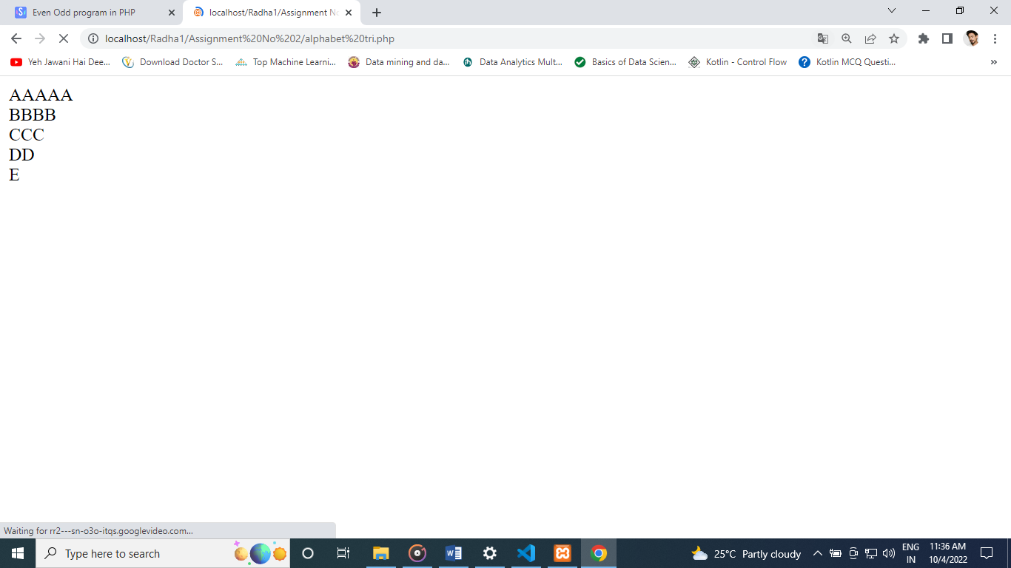

**18. Write a PHP program to print number triangle.**

<?php

echo "<pre>";

for($i=1;$i<=10;$i++){

for($j=1;$j<=$i;$j++){

echo $j."&nbsp;";

if($j==$i){

echo "";

echo "<br/>";

}

}

}

echo "</pre>";

?>

Output :

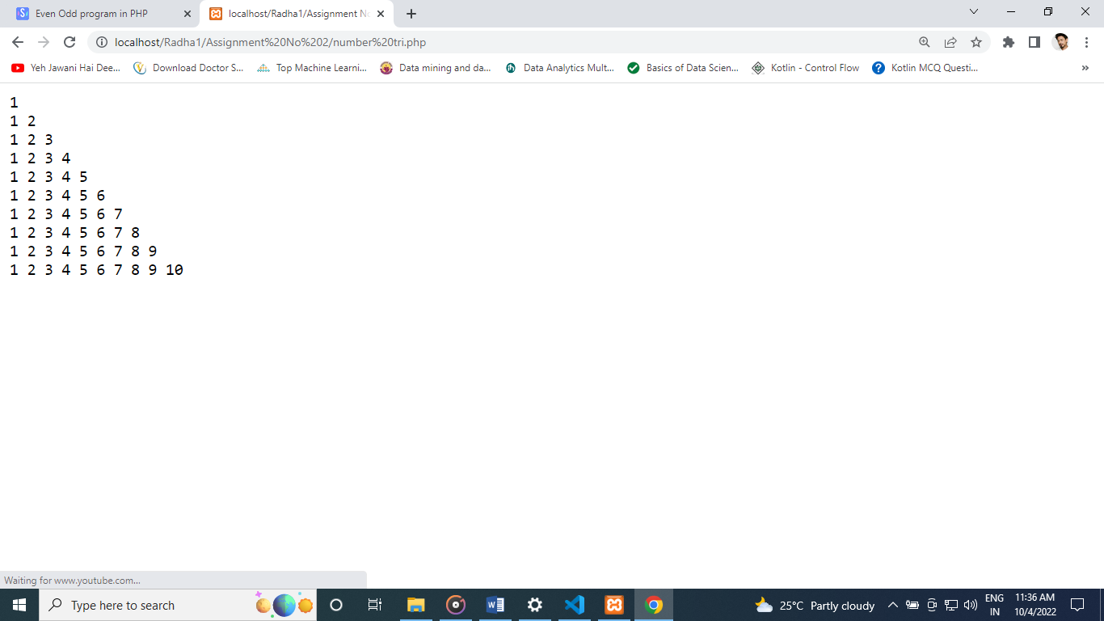

**19. Write a PHP programs to print star triangle.**

<?php

$alpha = range('A', 'Z');

for($i=0; $i<5; $i++){

for($j=5; $j>$i; $j--){

echo $alpha[$i];

}

echo "<br>";

}

?>

Assignment 3

1.

<?php

for($x=1; $x<=16; $x++)

{

if($x< 16)

{

echo "$x-";

}

else

{

echo "$x"."\n";

}

}

?>

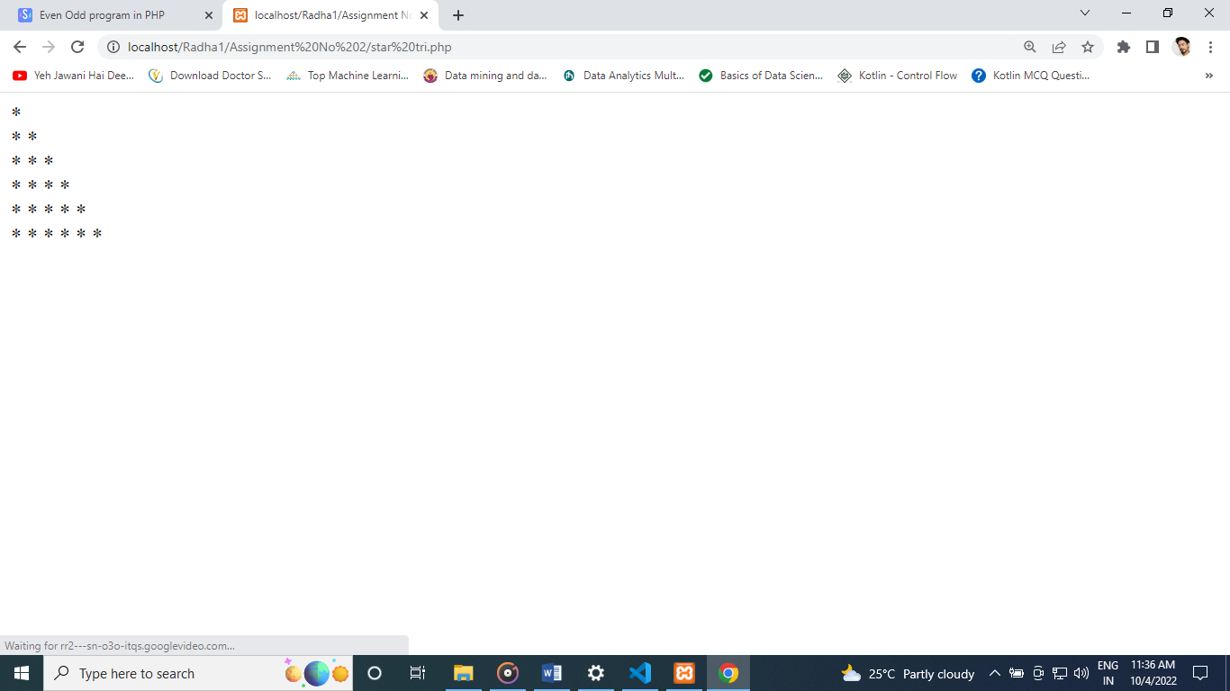

**Assignment No 3**

1. **Create a script that displays 2-4-6-8-10-12-14-16 on one line. There will be no hyphen(-) at starting and ending position.**

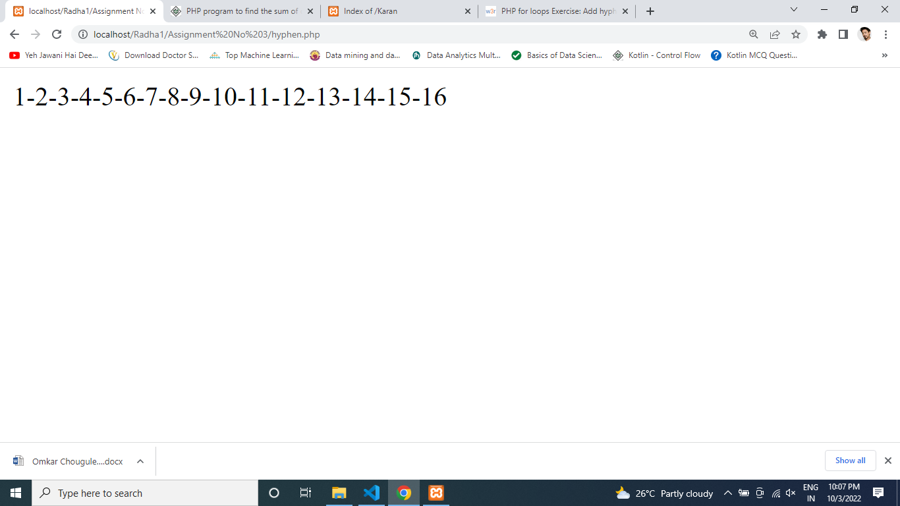

**2. Create a script using a for loop to add all the integers between 0 and 50 and display the total.**

<?php

$sum = 0;

for($x=1; $x<=50; $x++)

{

$sum +=$x;

}

echo "The sum of the numbers 0 to 50 is $sum"."\n";

?>

Output :

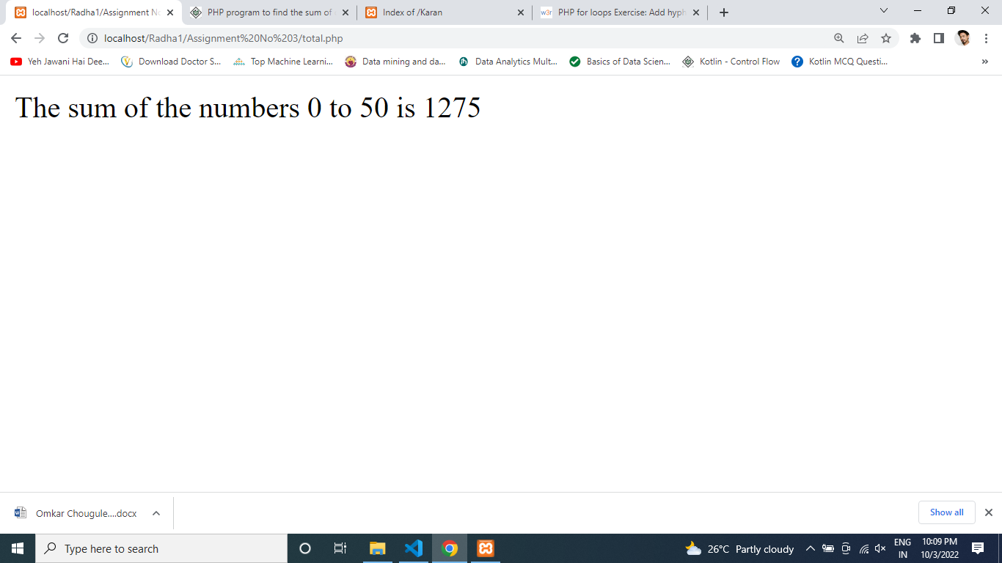

**3. Create a script to construct the following pattern, using nested for loop**

<!DOCTYPE html>

<html>

<head>

<meta charset="UTF-8">

<title>Code4Example</title>

</head>

<body>

<?php

for($x=1;$x<=5;$x++)

{

for ($y=1;$y<=$x;$y++)

{

echo "*";

if($y< $x)

{

echo " ";

}

}

echo "<br>";

}

?>

</body>

</html>

Output :

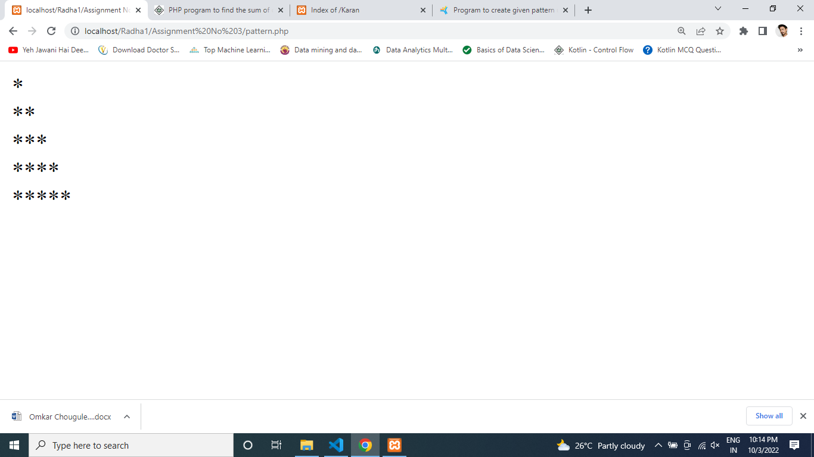

**4. Create a script to construct the following pattern, using a nested for loop**

<!DOCTYPE html>

<html>

<head>

<meta charset="UTF-8">

<title>Code4Example</title>

</head>

<body>

<?php

$n=5;

for($i=1; $i<=$n; $i++)

{

for($j=1; $j<=$i; $j++)

{

echo ' * ';

}

echo '<br>';

}

for($i=$n; $i>=1; $i--)

{

for($j=1; $j<=$i; $j++)

{

echo ' * ';

}

echo '<br>';

}

?>

</body>

</html>

Output :

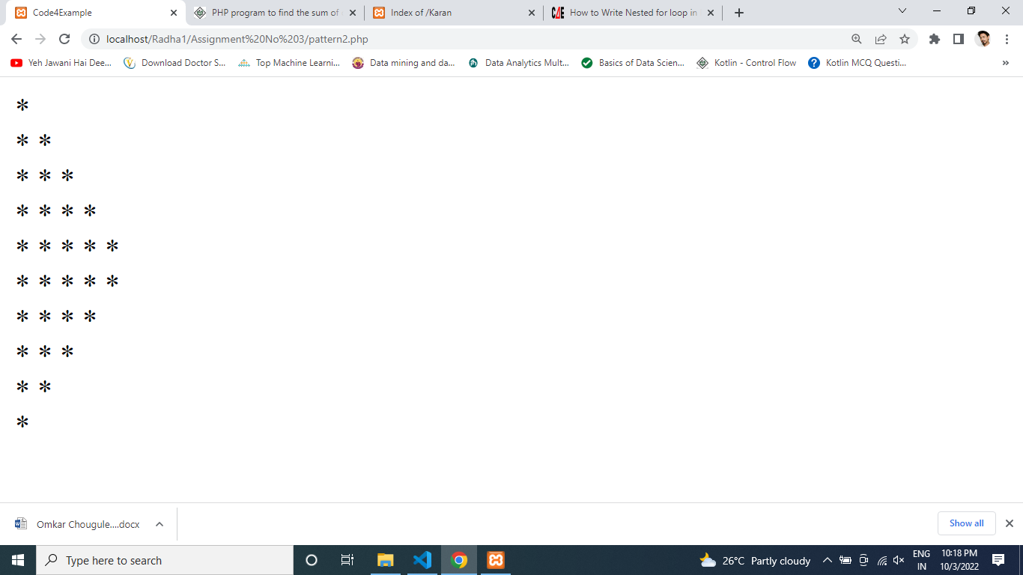

**5. Write a PHP script that creates the following table using for loops. Add cellpadding="3px" and cellspacing="0px" to the table tag.**

<?php

echo "<table border =\"1\" style='border-collapse: collapse'>";

for ($row=1; $row <= 10; $row++) {

echo "<tr> \n";

for ($col=1; $col <= 10; $col++) {

$p = $col * $row;

echo "<td>$p</td> \n";

}

echo "</tr>";

}

echo "</table>";

?>

Output :

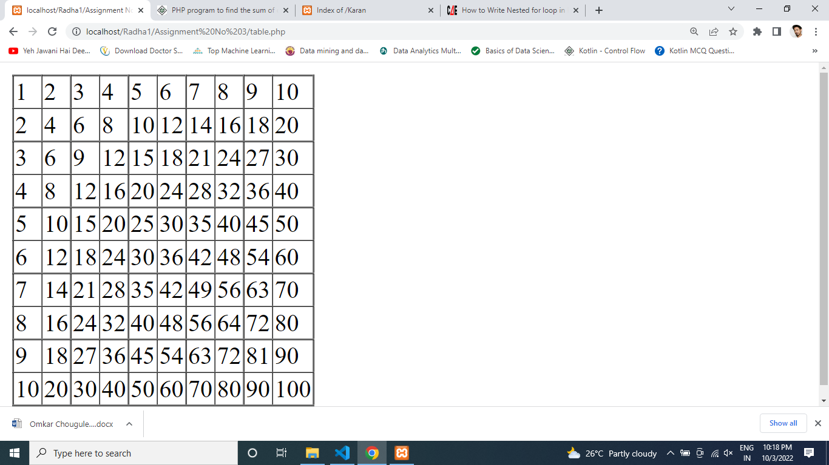

**Assignment No 4**

**1. Write a function to calculate the factorial of a given number .**

<?php

$input=5;

$fact =1;

for($i=$input; $i>=1;$i--) {

$fact = $fact * $i;

}

echo '<br>'. 'The factorial of the number 5 is '. $fact

?>

Output :

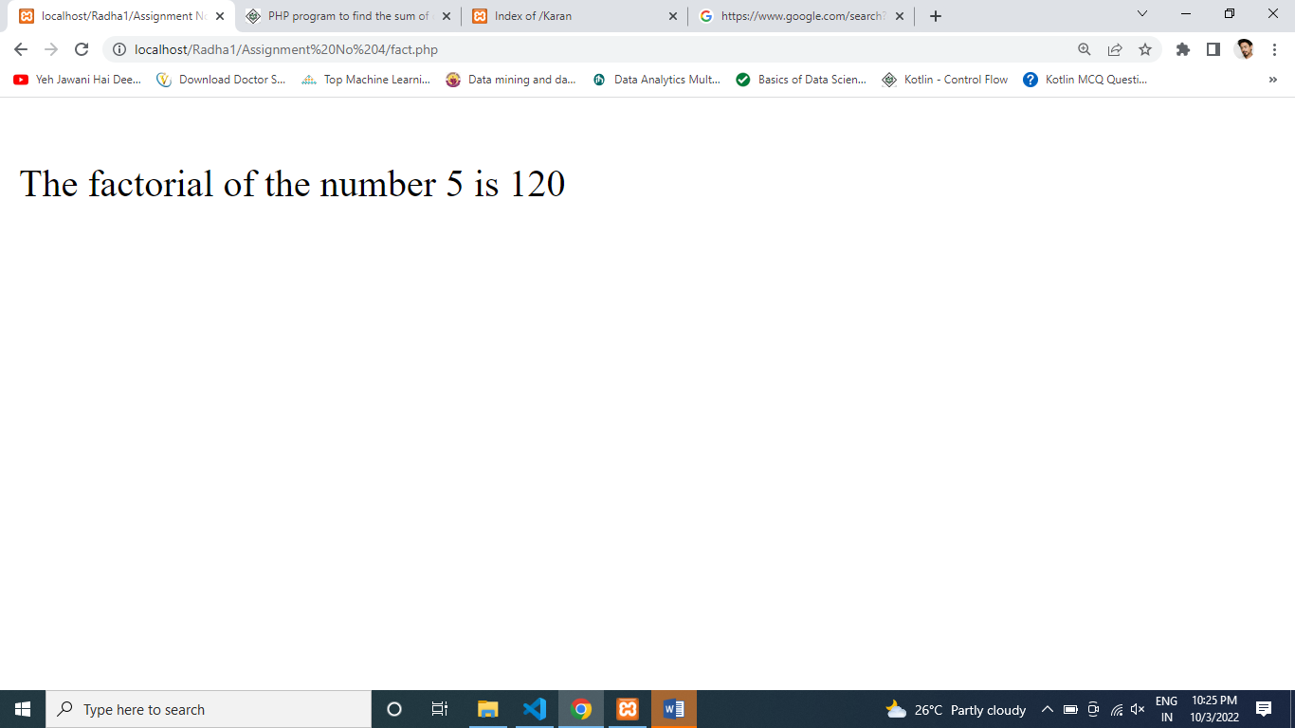

**2. Write a function to reverse a string.**

<?php

function reverse_string($str1)

{

$n = strlen($str1);

if($n == 1)

{

return $str1;

}

else

{

$n--;

return reverse_string(substr($str1,1, $n)) . substr($str1, 0, 1);

}

}

print_r(reverse_string('1234')."\n");

?>

Output :

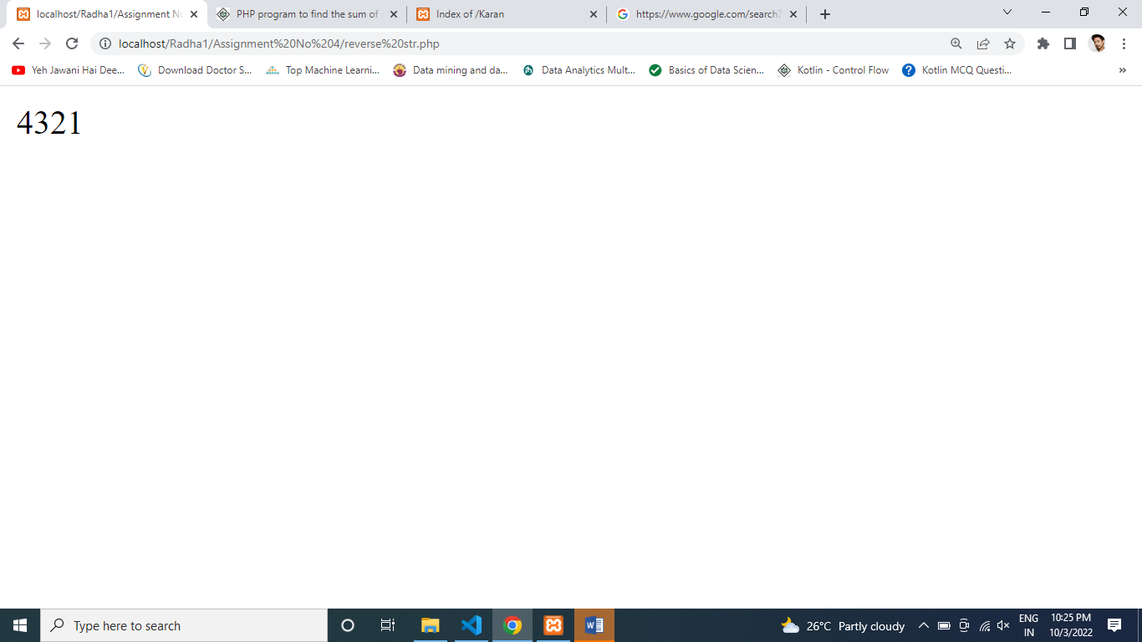

**3. Write a PHP function that checks whether a string is all uppercase.**

<?php

$str = 'AUSTRALIA';

if (ctype_upper($str)) {

echo "Word has all uppercase characters!\n";

} else {

echo "Word does not have all uppercase characters!\n";

}

?>

Output :

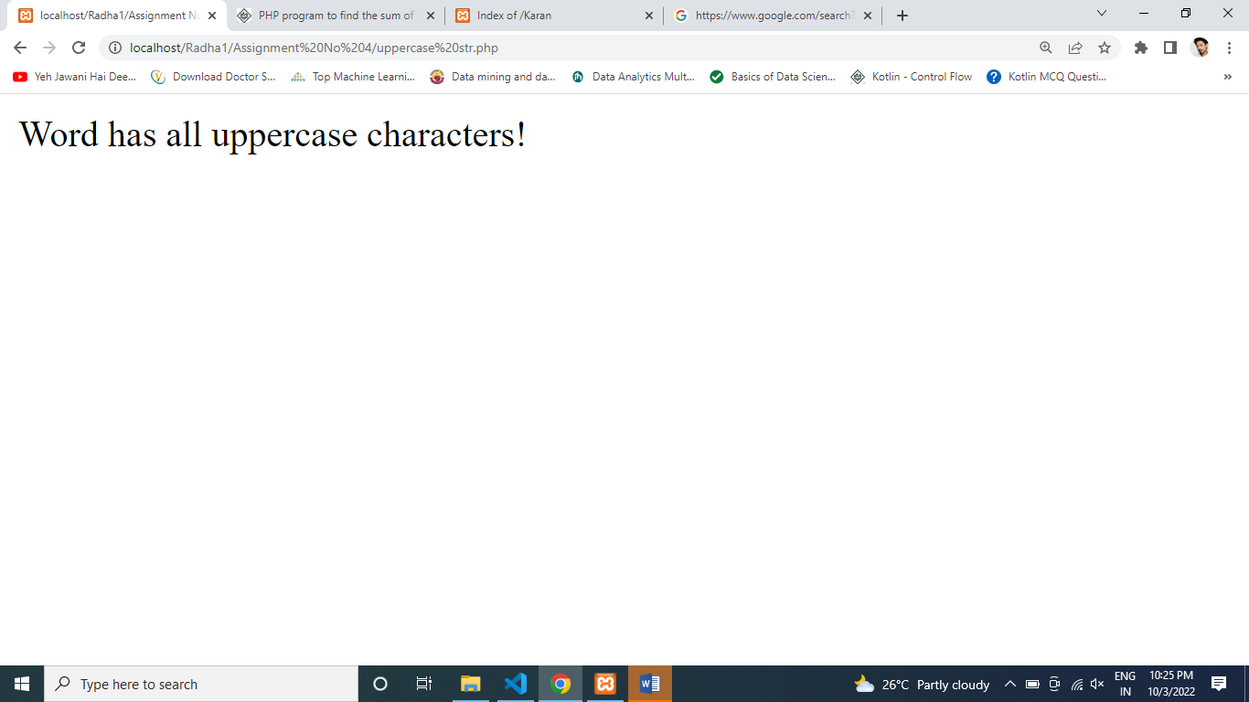

**4. Write a PHP program to check if a person is eligible to vote**

<?php

function check_vote() //function has been declared

{

$name = "Person";

$age = 19;

if ($age >= 18) {

echo $name . ", Is Eligible For Vote";

} else {

echo $name . ", is eligible for vote. ";

}

}

check_vote(); //function has been called

?>

Output :

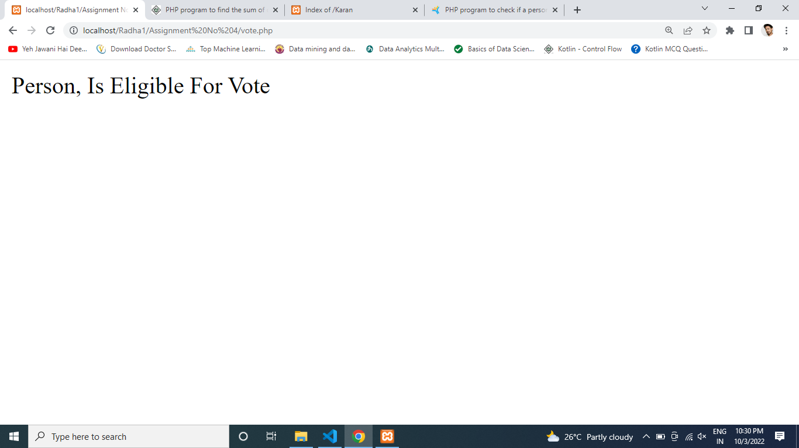

**5. Write a PHP program to calculate area of rectangle**

<?php

function rect_area($length = 2, $width = 4)

{

$area = $length * $width;

echo "Area Of Rectangle with length " . $length . " & width " . $width . " is " . $area ;

}

rect_area();

?>

Output :

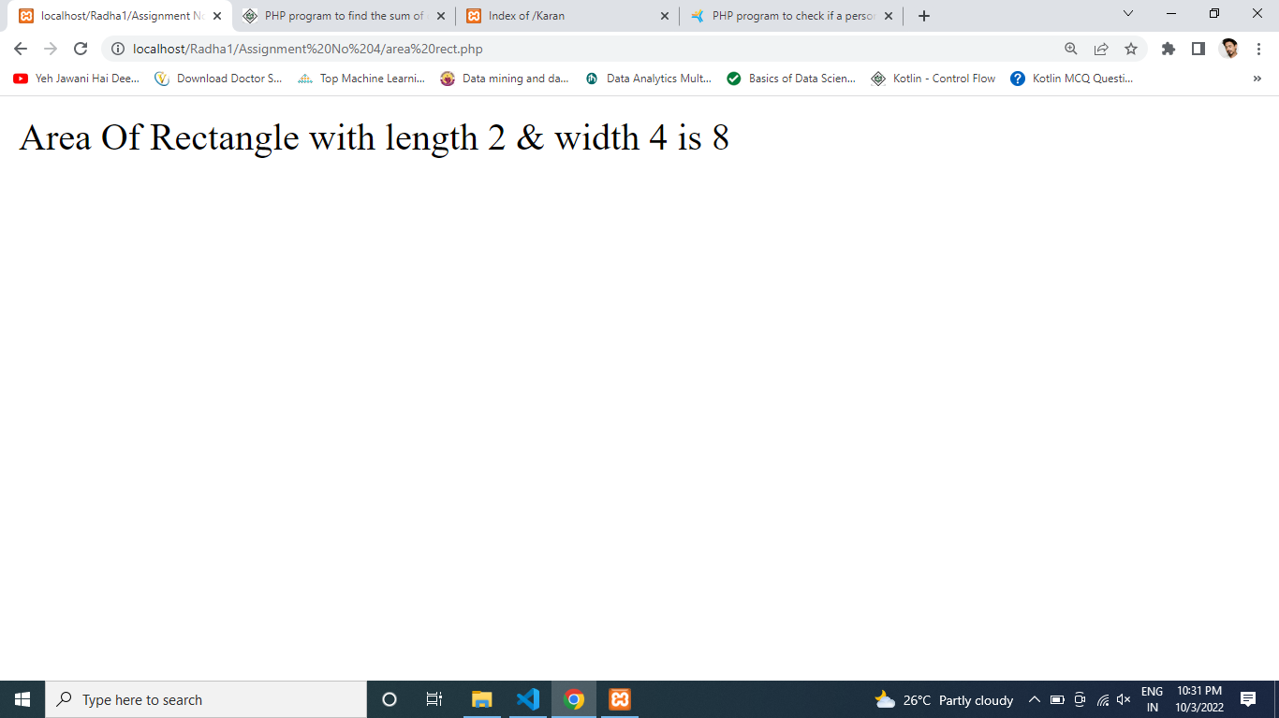



**Assignment No: 5**

**Q . 1 $color = array(4=>’white’, 6 => ‘green’, 11=>’red’);**

**Write a PHP script to get the first element of the above array.**

<?php

$color = array(4=> 'white',6 => 'green',11=>'red');

print_r($color);

echo "<br>";

echo $color[4];

?>

**Output:**

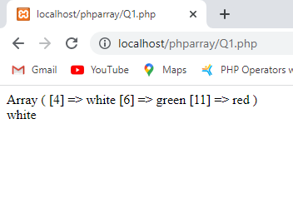

**Q. 2 Write a PHP script that inserts a new item in an array position.**

<?php

$original = array( '1','2','3','4','5' );

echo 'Original array : '."\n";

foreach ($original as $x)

{echo "$x ";}

$inserted = '8';

array_splice( $original, 3, 0, $inserted );

echo " \n After inserting '8' the array is : "."\n";

foreach ($original as $x)

{echo "$x ";}

echo "\n"

?>

**Output:**

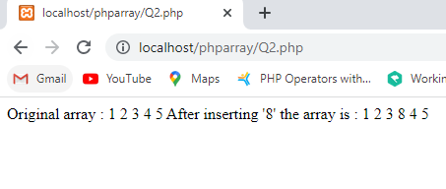

**Q. 3 Write a PHP program to merge(by index) the following two arrays.**

**Sample arrays:**

**$array1 = array(array(77,87), array(23,45));**

**$array2 = array(“w3resource”, “com”);**

<?php

$array1 = array(array(77, 87), array(23, 45));

$array2 = array("w3resource", "com");

function merge_arrays_by_index($x, $y)

{

$temp = array(); $temp[] = $x; if(is_scalar($y))

{

$temp[] = $y;

}

else

{

foreach($y as $k => $v)

{

$temp[] = $v;

}

}

return $temp;

}

echo '<pre>'; print_r(array_map('merge_arrays_by_index',$array2, $array1));

?>

**Output:**

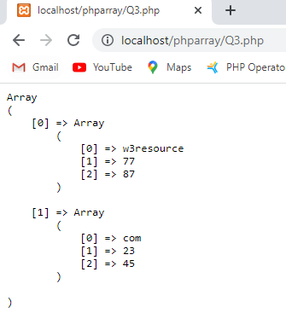

# Assignment No: 6

#### Design a registration Form using validation in PHP

<!DOCTYPE html>

<html>

<head>

<style>

.error {color: #FF0001;}

</style>

</head>

<body>

<?php

// define variables to empty values

$nameErr = $emailErr = $mobilenoErr = $genderErr = $websiteErr = $agreeErr = "";

$name = $email = $mobileno = $gender = $website = $agree = "";

//Input fields validation

if ($_SERVER["REQUEST_METHOD"] == "POST") {

//String Validation

if (empty($_POST["name"])) {

$nameErr = "Name is required";

} else {

$name = input_data($_POST["name"]);

// check if name only contains letters and whitespace if (!preg_match("/^[a-zA-Z ]*$/",$name)) {

$nameErr = "Only alphabets and white space are allowed";

}

}

//Email Validation

if (empty($_POST["email"])) {

$emailErr = "Email is required";

} else {

$email = input_data($_POST["email"]);

// check that the e-mail address is well-formed

if (!filter_var($email, FILTER_VALIDATE_EMAIL)) {

$emailErr = "Invalid email format";

}

}

//Number Validation

if (empty($_POST["mobileno"])) {

$mobilenoErr = "Mobile no is required";

} else {

$mobileno = input_data($_POST["mobileno"]);

// check if mobile no is well-formed

if (!preg_match ("/^[0-9]*$/", $mobileno) ) {

$mobilenoErr = "Only numeric value is allowed.";

}

//check mobile no length should not be less and greator than 10 if (strlen ($mobileno) != 10) {

$mobilenoErr = "Mobile no must contain 10 digits.";

}

}

//URL Validation

if (empty($_POST["website"])) {

$website = "";

} else {

$website = input_data($_POST["website"]);

// check if URL address syntax is valid

if (!preg_match("/\b(?:(?:https?|ftp):\/\/|www\.)[-a-z0-

9+&@#\/%?=~_|!:,.;]*[-a-z0-9+&@#\/%=~_|]/i",$website)) {

$websiteErr = "Invalid URL";

}

}

//Empty Field Validation

if (empty ($_POST["gender"])) {

$genderErr = "Gender is required";

} else {

$gender = input_data($_POST["gender"]);

}

//Checkbox Validation

if (!isset($_POST['agree'])){

$agreeErr = "Accept terms of services before submit.";

} else {

$agree = input_data($_POST["agree"]);

}

}

function input_data($data) {

$data = trim($data);

$data = stripslashes($data);

$data = htmlspecialchars($data); return $data;

}

?>

<h2>Registration Form</h2>

<span class = "error">* required field </span>

<br><br>

<form method="post" action="<?php echo htmlspecialchars($_SERVER["PHP_SELF"]); ?>" >

Name:

<input type="text" name="name">

<span class="error">* <?php echo $nameErr; ?></span>

<br><br> E-mail:

<input type="text" name="email">

<span class="error">* <?php echo $emailErr; ?></span>

<br><br> Mobile No:

<input type="text" name="mobileno">

<span class="error">* <?php echo $mobilenoErr; ?></span>

<br><br> Website:

<input type="text" name="website">

<span class="error"><?php echo $websiteErr; ?></span>

<br><br> Gender:

<input type="radio" name="gender" value="male"> Male

<input type="radio" name="gender" value="female"> Female

<input type="radio" name="gender" value="other"> Other

<span class="error">* <?php echo $genderErr; ?></span>

<br><br>

Agree to Terms of Service:

<input type="checkbox" name="agree">

<span class="error">* <?php echo $agreeErr; ?></span>

<br><br>

<input type="submit" name="submit" value="Submit">

<br><br>

</form>

<?php

if(isset($_POST['submit'])) {

if($nameErr == "" && $emailErr == "" && $mobilenoErr == "" && $genderErr == "" && $websiteErr == "" && $agreeErr == "") {

echo "<h3 color = #FF0001><b>You have sucessfully registered.</b></h3>"; echo "<h2>Your Input:</h2>";

echo "Name: " .$name; echo "<br>";

echo "Email: " .$email; echo "<br>";

echo "Mobile No: " .$mobileno; echo "<br>";

echo "Website: " .$website; echo "<br>";

echo "Gender: " .$gender;

} else {

echo "<h3><b>You didn't filled up the form correctly.</b></h3>";

}

}

?>

</body>

</html>

**Output-**

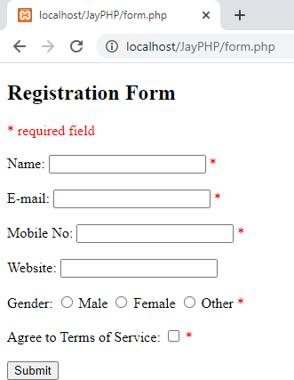

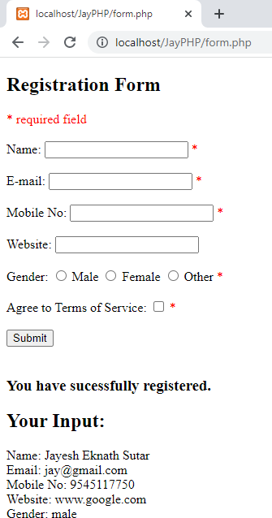

#### Create a register form

<!DOCTYPE html>

<html>

<head>

<meta name="viewport" content="width=device-width, initial-scale=1">

<style> body {

font-family: Arial, Helvetica, sans-serif; background-color: black;

}

* {

box-sizing: border-box;

}

/* Add padding to containers */

.container { padding: 16px;

background-color: white;

}

/* Full-width input fields */ input[type=text], input[type=password] { width: 100%;

padding: 15px; margin: 5px 0 22px 0; display: inline-block; border: none; background: #f1f1f1;

}

input[type=text]:focus, input[type=password]:focus { background-color: #ddd;

outline: none;

}

/* Overwrite default styles of hr */ hr {

border: 1px solid #f1f1f1; margin-bottom: 25px;

}

/* Set a style for the submit button */

.registerbtn {

background-color: #04AA6D; color: white;

padding: 16px 20px; margin: 8px 0; border: none; cursor: pointer; width: 100%;

opacity: 0.9;

}

.registerbtn:hover { opacity: 1;

}

/* Add a blue text color to links */ a {

color: dodgerblue;

}

/* Set a grey background color and center the text of the "sign in" section */

.signin {

background-color: #f1f1f1; text-align: center;

}

</style>

</head>

<body>

<form action="/action_page.php">

<div class="container">

<h1>Register</h1>

<p>Please fill in this form to create an account.</p>

<hr>

<label for="email"><b>Email</b></label>

<input type="text" placeholder="Enter Email" name="email" id="email" required>

<label for="psw"><b>Password</b></label>

<input type="password" placeholder="Enter Password" name="psw" id="psw" required>

<label for="psw-repeat"><b>Repeat Password</b></label>

<input type="password" placeholder="Repeat Password" name="psw-repeat" id="psw-repeat" required>

<hr>

<p>By creating an account you agree to our <a href="#">Terms & Privacy</a>.</p>

<button type="submit" class="registerbtn">Register</button>

</div>

<div class="container signin">

<p>Already have an account? <a href="#">Sign in</a>.</p>

</div>

</form>

</body>

</html>

### Output-

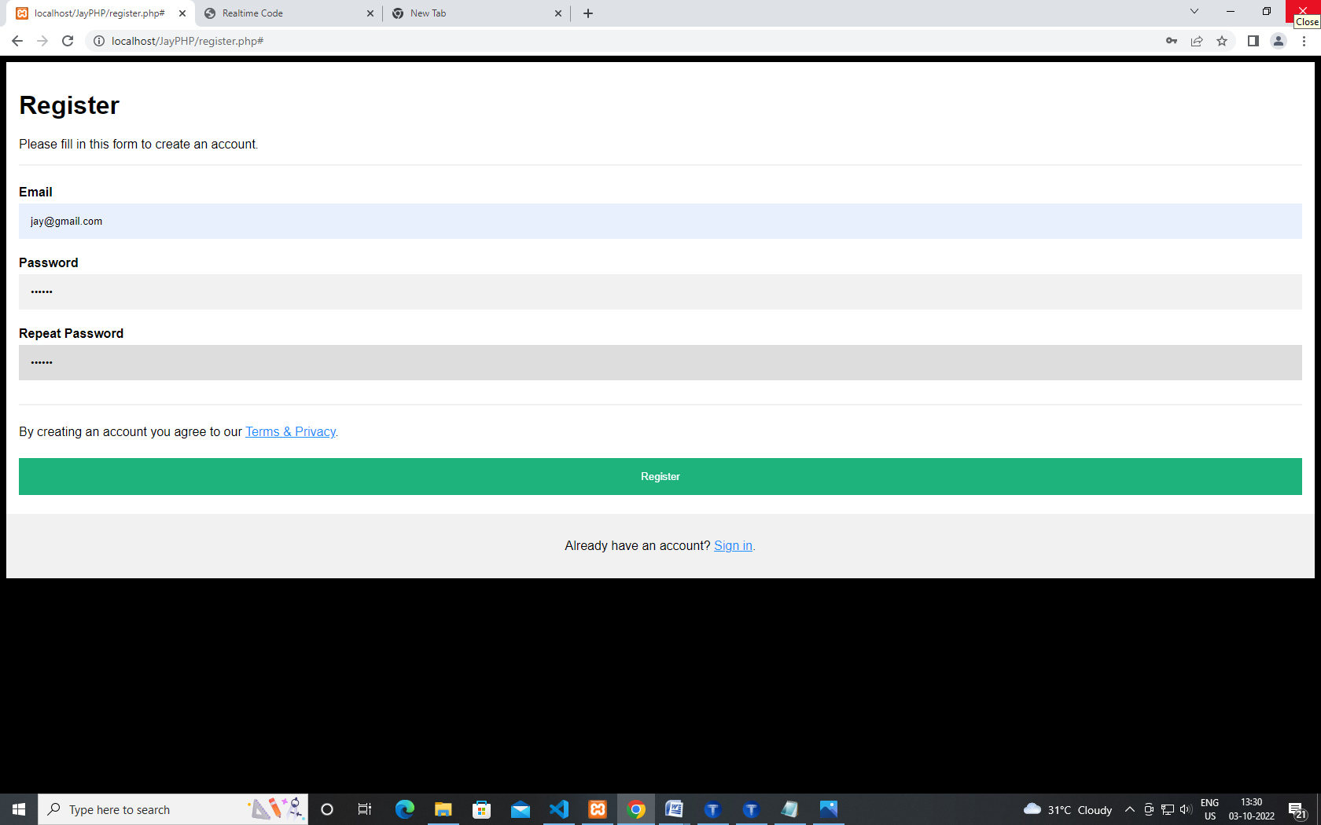

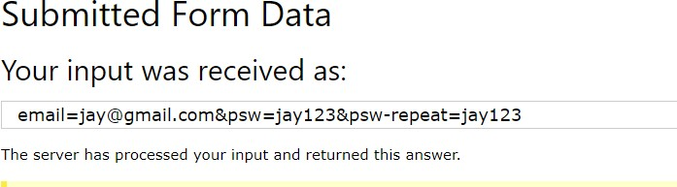

#### Create a signup form

<!DOCTYPE html>

<html>

<style>

body {font-family: Arial, Helvetica, sans-serif;}

* {box-sizing: border-box;}

/* Full-width input fields */

input[type=text], input[type=password] { width: 100%;

padding: 15px; margin: 5px 0 22px 0; display: inline-block; border: none; background: #f1f1f1;

}

/* Add a background color when the inputs get focus */ input[type=text]:focus, input[type=password]:focus { background-color: #ddd;

outline: none;

}

/* Set a style for all buttons */ button {

background-color: #04AA6D; color: white;

padding: 14px 20px; margin: 8px 0; border: none; cursor: pointer; width: 100%;

opacity: 0.9;

}

button:hover { opacity:1;

}

/* Extra styles for the cancel button */

.cancelbtn {

padding: 14px 20px; background-color: #f44336;

}

/* Float cancel and signup buttons and add an equal width */

.cancelbtn, .signupbtn { float: left;

width: 50%;

}

/* Add padding to container elements */

.container { padding: 16px;

}

/* The Modal (background) */

.modal {

display: none; /* Hidden by default */ position: fixed; /* Stay in place */

z-index: 1; /* Sit on top */ left: 0;

top: 0;

width: 100%; /* Full width */ height: 100%; /* Full height */

overflow: auto; /* Enable scroll if needed */ background-color: #474e5d;

padding-top: 50px;

}

/* Modal Content/Box */

.modal-content { background-color: #fefefe;

margin: 5% auto 15% auto; /* 5% from the top, 15% from the bottom and centered */

border: 1px solid #888;

width: 80%; /* Could be more or less, depending on screen size */

}

/* Style the horizontal ruler */ hr {

border: 1px solid #f1f1f1; margin-bottom: 25px;

}

/* The Close Button (x) */

.close {

position: absolute;

right: 35px;

top: 15px;

font-size: 40px; font-weight: bold; color: #f1f1f1;

}

.close:hover,

.close:focus { color: #f44336; cursor: pointer;

}

/* Clear floats */

.clearfix::after { content: ""; clear: both; display: table;

}

/* Change styles for cancel button and signup button on extra small screens */ @media screen and (max-width: 300px) {

.cancelbtn, .signupbtn { width: 100%;

}

}

</style>

<body>

<h2>Modal Signup Form</h2>

<button onclick="document.getElementById('id01').style.display='block'" style="width:auto;">Sign Up</button>

<div id="id01" class="modal">

<span onclick="document.getElementById('id01').style.display='none'" class="close" title="Close Modal">&times;</span>

<form class="modal-content" action="/action_page.php">

<div class="container">

<h1>Sign Up</h1>

<p>Please fill in this form to create an account.</p>

<hr>

<label for="email"><b>Email</b></label>

<input type="text" placeholder="Enter Email" name="email" required>

<label for="psw"><b>Password</b></label>

<input type="password" placeholder="Enter Password" name="psw" required>

<label for="psw-repeat"><b>Repeat Password</b></label>

<input type="password" placeholder="Repeat Password" name="psw-repeat" required>

<label>

<input type="checkbox" checked="checked" name="remember" style="margin- bottom:15px"> Remember me

</label>

<p>By creating an account you agree to our <a href="#" style="color:dodgerblue">Terms & Privacy</a>.</p>

<div class="clearfix">

<button type="button" onclick="document.getElementById('id01').style.display='none'" class="cancelbtn">Cancel</button>

<button type="submit" class="signupbtn">Sign Up</button>

</div>

</div>

</form>

</div>

<script>

// Get the modal

var modal = document.getElementById('id01');

// When the user clicks anywhere outside of the modal, close it window.onclick = function(event) {

if (event.target == modal) {

modal.style.display = "none";

}

}

</script>

</body>

</html>

### Output-

